**Praise to our lord and saviour svb <3**

(Always seducing towards a contradiction)

# “As soon as you ask me that kind of question, I'm always baffled.

# Do you think there is stuff that I do in this lecture that you don't need to know?

# Do you think I'm trying to keep you off the street or something?”

**Just look at 2021 answers basically the same**

**Do 2-3 past papers or just look at their answers, makes this exam p easy**

Steffen is love steffen is life 😊

Steffen with an E my friends

The holy scriptures<3

2022 updated notes: <https://www.doc.ic.ac.uk/~svb/Schiele/>

Cheat sheet at: <https://www.doc.ic.ac.uk/~svb/Schiele/81B58D1Ad01.jpeg>

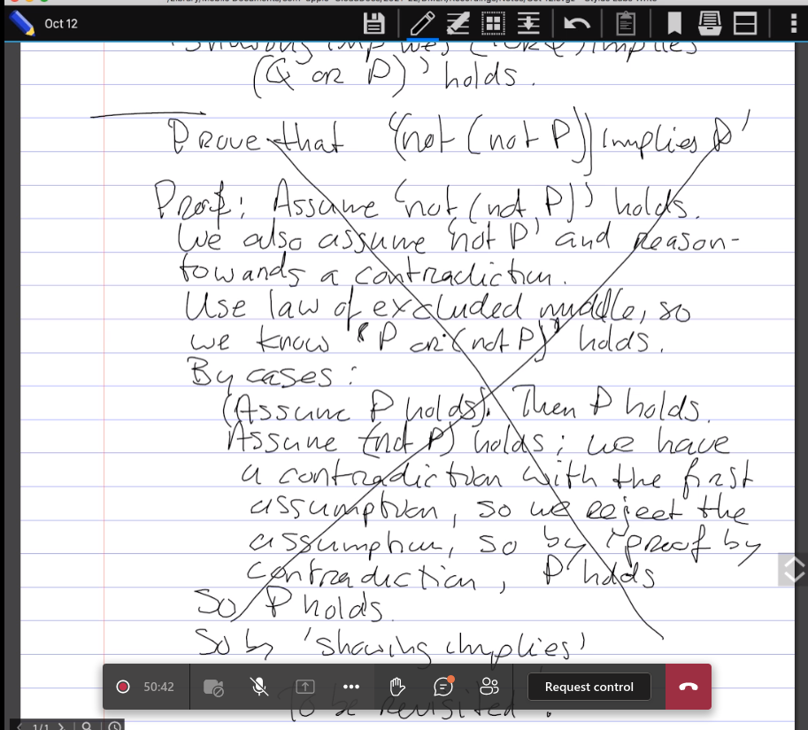O

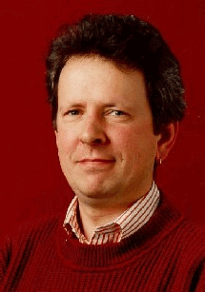

Steffen van based

z

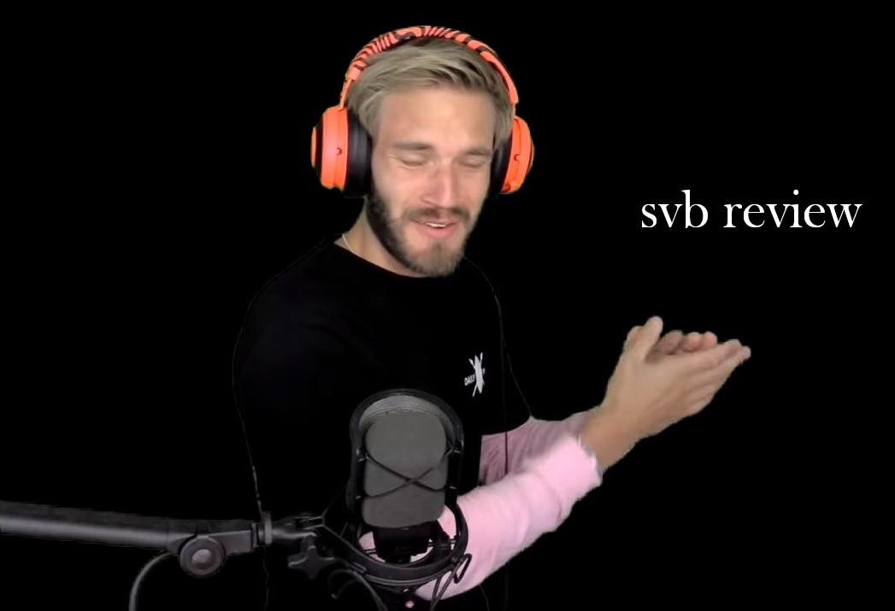

Average amazon user - 10/10 would recommend my respect for him is uncountable (no bijection exists between the set of natural numbers and our respect for steffen)

?/10 - would have asked him what his preferred rating is but he doesn’t like being asked questions